Honors Geometry: Extra Practice and Challenge Unit 1

1.) line AB with the equation of y = 7/5 (x) + 5 and is parallel to a line that goes through the points (-2,-6) and (y +2, y). Plot the point (y+2, y).

2.) a line is perpendicular to the equation 3x + 2y = -6 and goes through the point (4, -6). Write the equation of the line in 3 different ways ( slope-intercept, standard and point-slope form)

3.) ML has the endpoints M(-2,3) and L(-5,4) find the image of ML after a 180 degree rotation about the point (0,5)

4.) Given the point Q(-2,3) find the image after each rotation of point Q. You can use graph paper, but write the final transformed points coordinates.

a.) (x – 5, y + 2) b.) rotate 90 degree clockwise about origin

c.) rotate 270 degrees counterclockwise about origin.

5.) Is there a relationship between part b and c of #4? Is there a short way of rotating points about the origin without graphing? Is so explain in detail how you would instruct someone to rotate an object 90 degrees about the origin.

6.) Reflect figure B across line l
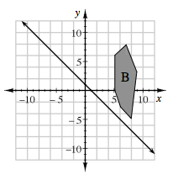

7.) What is the order and degrees of rotational symmetry that a regular pentagon would have?

8.) What single transformation would result from a reflection over two parallel lines?

